Fixguru Autcount Integration
@Muhammad Azib Iqbal Bin Harun

Doctype
Doctype need to return external ID

Pull after the cut-off date
Clarify with the client
QTN
SO
SI
CN
DN
RN
DO
Payment Entry
Delivery Method - need to test
Stock Balance
Stock Recon 12 am & 7 am
Warehouse TBC
- Shelf in DO
UOM

Pricing
Min/Max pricing
Historical pricing
- Get historical pricing and discounts from the price historical report
- Based on the debtor code and the item
- Custom endpoint to pull the data
- No need to access it from the doctype
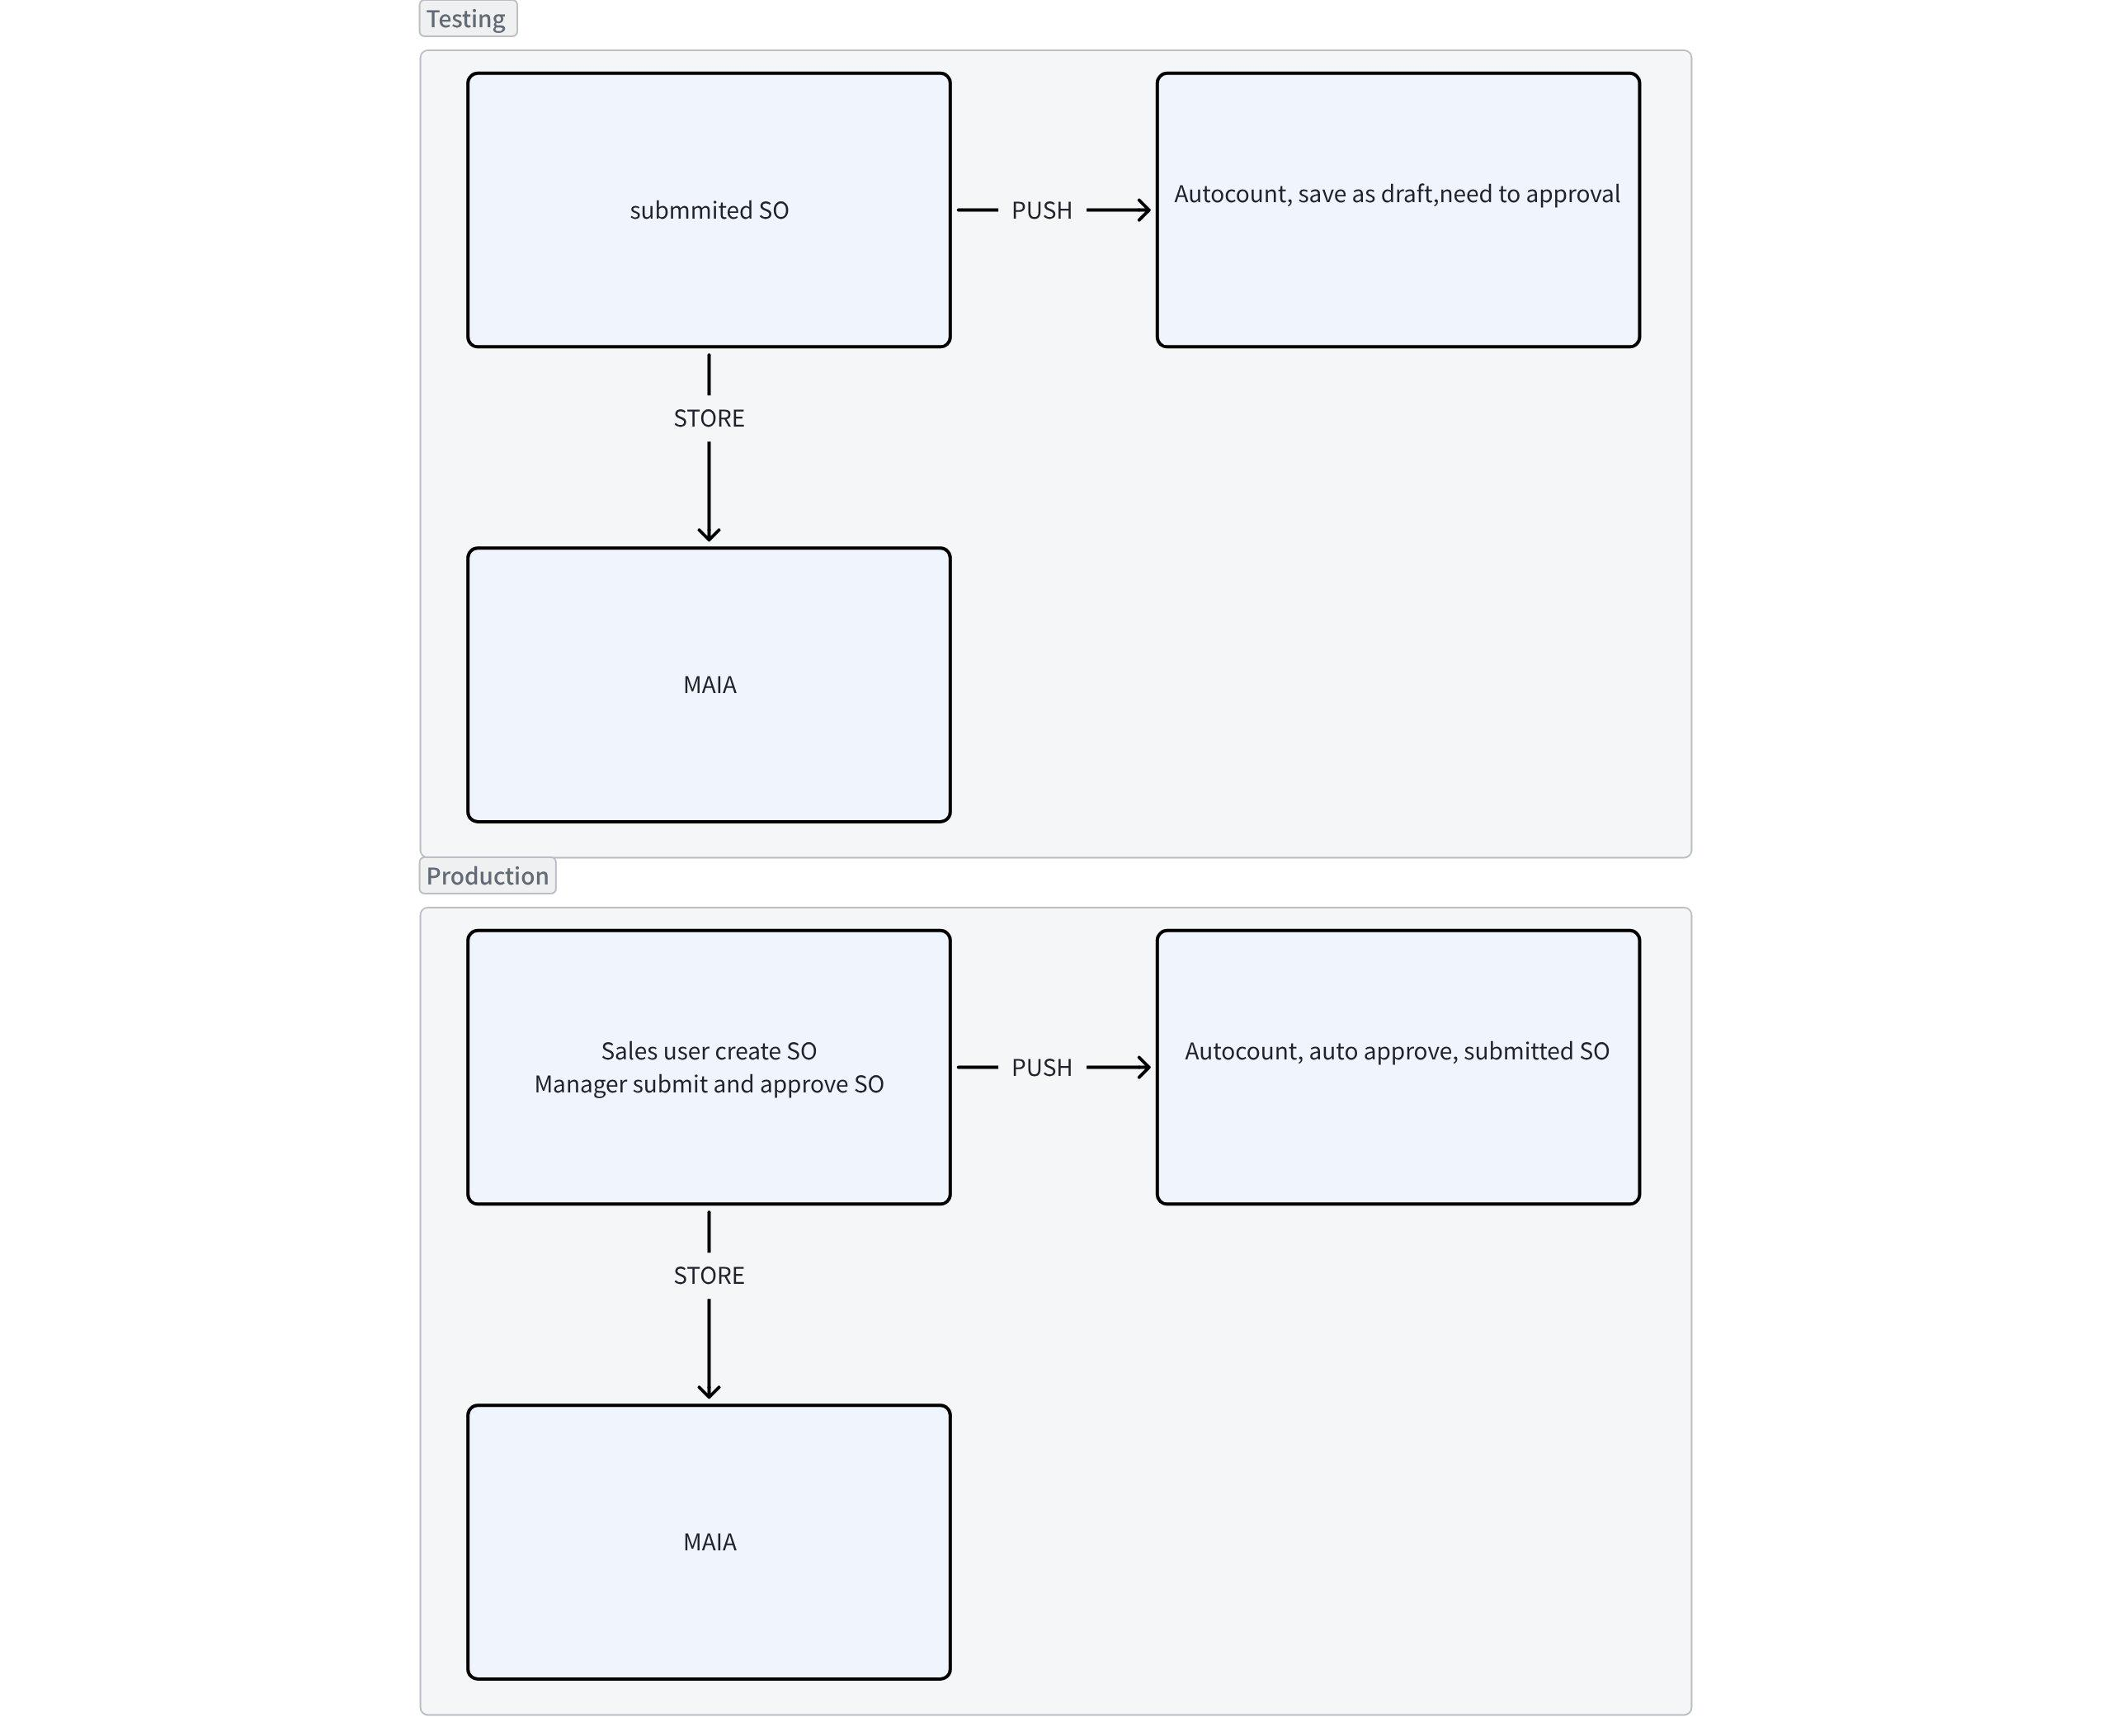

Master Data
Item
- BOM - Scoped
- Volume - Pulled
- Volume UOM - Need tbc
- Need to return item code into MAIA as SKU
- Confirm chatbot can surface it out
Customer
- General Tab - billing contact, billing address, delivery address
- Contact Tab - shipping contact, can be multiple
- Branch - shipping address, contact, can be multiple

Credit Limit
Credit limit approval was implemented before , need to retest,
Unpaid invoice & active customer , latest and recent doctype - clarify with client the flow
Pro > do > inv need inv to knock off , limit

PDF template
- Those submitted doctype (PI, SI, DO) pulled from Autocount - Done
- For draft doctype in MAIA, get html from the external template
- Fe side, refactor to add internal or external template, not sure want to override the native template ( fixguru got multiple templates)

Itemised vision
2-3 months
Prompt 2-3 month if dont buy
Customer dont commit
Past 1 month
Last year feb
Qtn = lookup
So = last inv
invoice

Purchasing 4 decimal
Einv 4 dec, report limit to show only 2 dec
Latest 3 transaction for historical pricing
Search Customer with phone number

